NNU

Faculty of Engineering and IT

Computer Engineering Department



Software Engineering Project

**Covid 19**

Supervision:

**Dr. Amjad Abu Hassan**

**Project Name**

* **Covid 19**
* **Team members**

1. Mahmoud basha
2. Ibraheem arda
3. Yacoob assi
4. Omar dere
5. Hosney ishtaya
6. Ataa shaqour
7. Amr eshtiwi

* **Accounts**
* **Git repository**: <https://github.com/amreshtiwi/advance_project_final.git> front-end
* **Git repository**:<https://github.com/Ataa00/Advance_Software_Covid19_project> back-end
* **Data base**: <https://covid19.who.int/data>
* **Zoom accounts.**
* **distribute work**

1. **mahmoud basha: documentation for the project .**
2. **omar dere: back end -service, control and repository for each class + connect the requests.**
3. **ibraheem arda: module and jwt security .**
4. **ataa shaqour: implement the overall back end to the new database .**
5. **hosney ishtaya: start up ,sign in and sign up page and connect them.**
6. **Yacoob assi: user page and admin page**
7. **Amr eshtiwi: heat map page , complete connection, overall project test and lead**

**Table of Contents**

1. Introduction

1.1.Purpose 4

1.2.Scope 4

1.3.References 4

1.4.Glossary 4

2. Overall Description 5

2.1.Product Perspective 5

2.2.Product Functions 5

2.2.1.Account Registration 5

2.2.2.Account Login 5

2.2.3.Search 5

2.2.4.Account Logout 5

2.3.User Characteristics 5

2.4.Admin Characteristics 5

2.5. languages 6

3. Specific Requirements 6

3.1.External Interface Requirements 6

3.2.Functional Requirements 7-9

3.3Performance Requirements 10

3.4.uml diagram 10

3.5 Design Constraints 11

3.6.Software System Attributes 11

3.7 Database side 11

**Software Requirements Specifications (SRS) for covid 19**

**1.1. Purpose:**

The main objective of (covid 19 app), is to review and edit the data in a visualize map that show the distributed numbers of covid around countries.

**1.2. Scope:**

Use data from multiple resource like world health organization and visualize the data with more choices for admin to edit the data for each country and search for details for each country

**1.3. References:**

# Stackoverflow and Youtube Overview

# World health organization

**1.4 Glossary**:

|  |  |
| --- | --- |
| **Term** | **Definition** |
| Covid 19 | The software component that shows the data to user in a better design as a heat map |
| user | Refers to all users who can access the app and use our services. |
| Database | Collection of all the information, i.e., covid stats. |
| admin | Person who has access to view and edit the data base |
| Account | Refers to the unique account maintained for each registered users /admin like username, email and password. |

**2.Overall Description**

**2.1 Product Perspective**

This product is an application used to view and represent the covid data daily using the world health organization data base to show number of new cases, new death, the cumulative cases and deaths.

Using heat map to visualize the data

**2.2 Product Functions**

Api system to use the world health organization data and represent it using heat map.

**2.2.1 Account Sign-up**

The account registration function shall allow users to register in the application by entering their information and a password.

**2.2.2 Account Log-in**

The account login function shall allow the registered users to enter the application in order to use it

Rationale: This function makes the user navigate into the application in two modes

1. admin mode
2. user mode

**2.3 User Characteristics**

The user can see the heat map and that show the degree of covid in that country and by clicking on country he can view the details of covid in that country

**2.4 Admin Characteristics**

admin can add new cases and deaths to each country and can search the data for all countries

**2.5 languages**

Front end: we use flutter and dart to make the front end due to good customization choices

And feeling and the ability to make fast test to gui on any device type.

Back end: we use postgreSQL due to its an open source sql, reduce cost ,provide security and scalability.

# External Interface Requirements:

**The project consists of many GUIs that makes communication with the user is easy.**

1. Start interface: user friendly interface as a start on running the app.
2. Registration interface: that work on making a covid 19 user account, and this interface contains information like name, email, username, and password.
3. Login interface: to make user or admin able to login to the covid 19 system by user name and password.
4. User interface: after log in as user provide data about any country we chose and a pop-up menu that has a log out and a heat map service.
5. Heat map: by this interface, the user can see a view of the world heat map of covid cases of each country and by clicking in we can see some details on covid statics.
6. Admin interface: the system provides features for the admin to edit the new cases and new deaths for each country.
7. Search by country for admin: provide you a search interface that show the details of each country and the ability to look for a country name.

# 

# Functional Requirements:

# 1.Register:

- The system should allow a non-registered user to create an account.

- The system should ask the user to enter username, password, first name, last name and email.

- The system should confirm that the password is valid, and the username is available and email is not used by another account.

- After the account is confirmed, the system should store the information in its database.

- The system should determine if the log in input is for user account or admin account and open the designed page for each.

# 2.Login:

- The system should ask the user for the username and password.

- After the system verifies the username and password, the user should proceed to the main interface.

# 3.heat map and user page:

# -The system should visualize the data from database as a heat map

# -The system should show more details about the country if chosen

# -The system should show more details and a chart to specific country

# 4.admin page and search:

# -The system should enable the admin to edit a new cases and deaths in a record.

# -The system should allow the admin to search for a specific country and read the data

# To make it more clear I will represent some of them as Tables :

* + 1. **User Registration**

|  |  |
| --- | --- |
| **Use Case Name** | Registration |
| **Precondition** | User create a new account |
| **Basic Path** | 1. The User registers for the service using his/her username, name, email and password. 2. On valid data the registration will be successful. 3. On successful registration the user now can log in and use the app |
| **Alternative Paths** | 1. If the user is already having an account he can log in immediately from the log in interface and if he/she doesn’t, he/she can create a new account from sign up interface 2. If the user sign out he can access log in again |
| **Postcondition** | After that user can use all services, we provide |

* + 1. **Heat map and user page**

|  |  |
| --- | --- |
| **Use Case Name** | Heat map, detailed and normal |
| **Trigger** | After successful registration as user |
| **Precondition** | The user/ should sign in to view the map. |
| **Basic Path** | 1. If the user sign in he can view the user page 2. If the user chose the pop up menu and click map he should be able to see the map and use it or he can sign-out. |
| **Post condition** | If user click on country, he can access special details for that country. |

### Admin and search

|  |  |
| --- | --- |
| **Use Case Name** | Admin page |
| **Trigger** | Sign in as admin |
| **Precondition** | Should be a registered admin In data base |
| **Basic Path** | 1. The admin log in the app 2. If log in successful he can edit the new cases and deaths for each country as a new record 3. He can search and view the data for all country |
| **Post condition** | The data edited or searched |

# Performance Requirements

The performance requirements are as follows:

* + - System login/logout shall take less than 5 seconds.
    - Searches shall return results within 10 seconds.
    - System shall support 10,00 simultaneous users.
    - Data should be displayed within 10 seconds.

# Uml diagram

The following diagram describes the attributes and the types of data that represented:

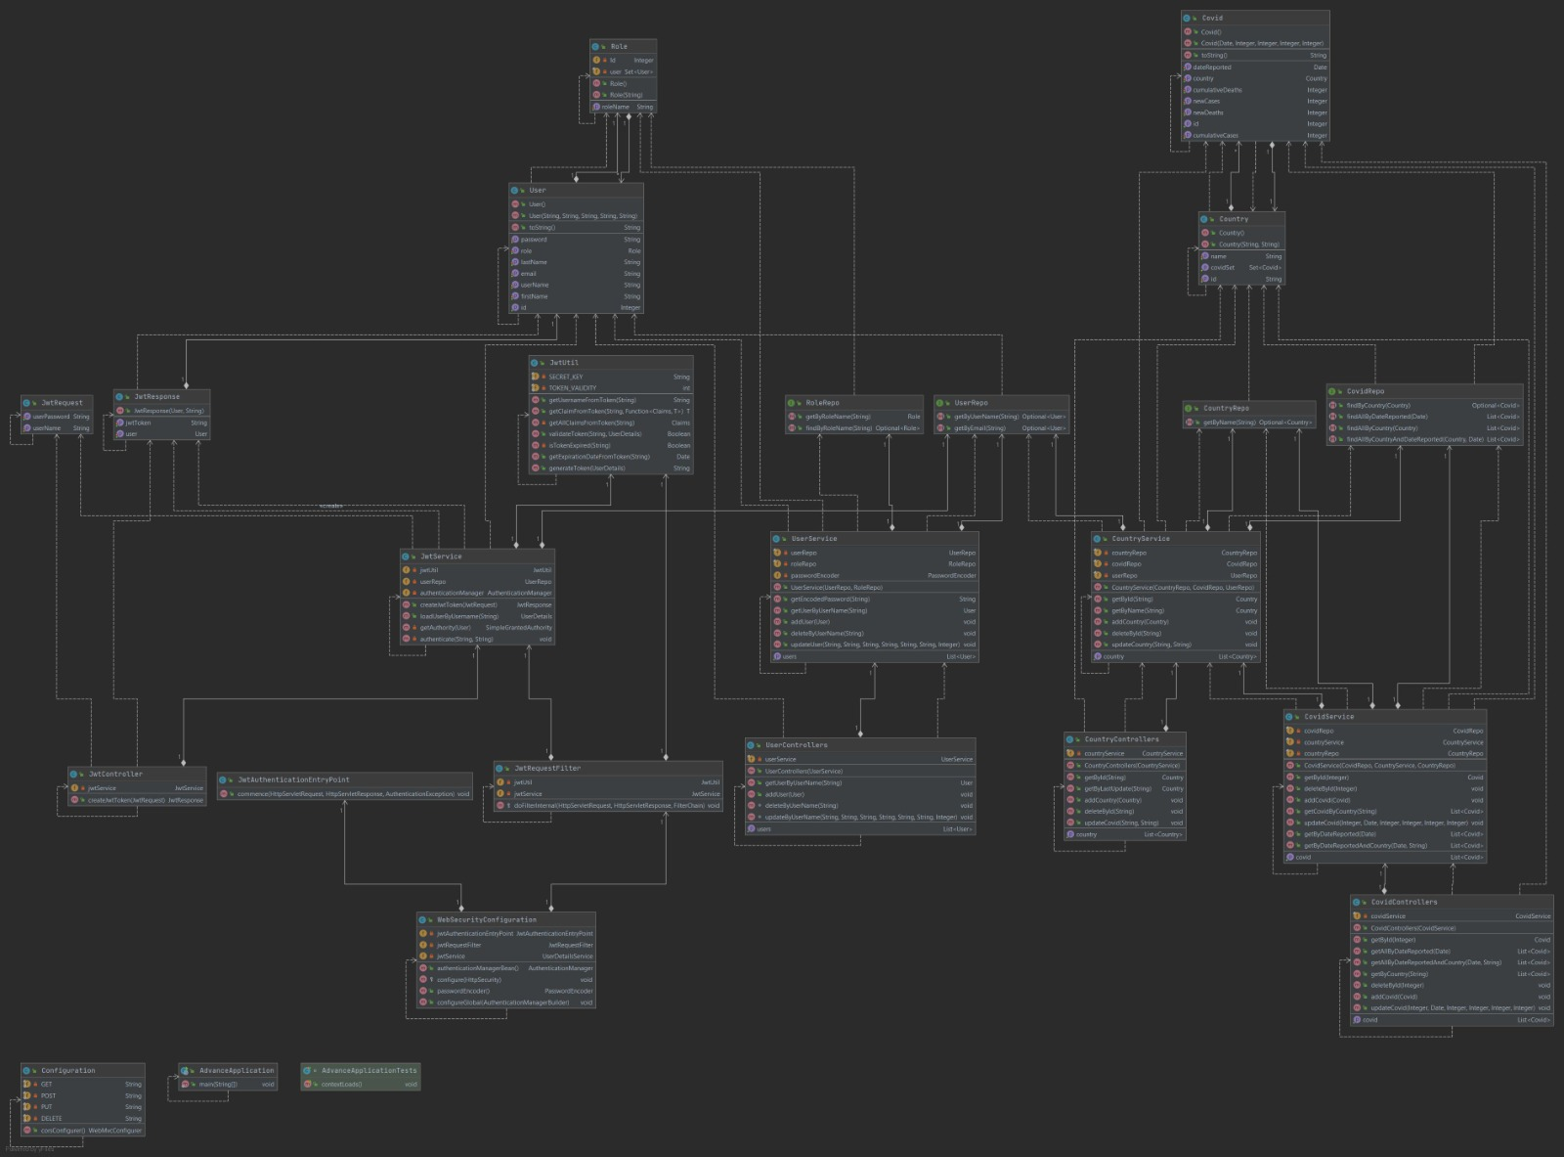

# 

# 3.5 Design Constraints

The covid 19 app shall conform to the following design constraints:

* Able to support smartphones (i.e., android, iPhone).
* System supports all web browsers (i.e., graphical, non-graphical).

# 

# 3.6 Software System Attributes

**1.Scalability**

The server should be able to work on thousands of users at same time

# 2.Availability

The map and data should be always available in time we run the app.

# 3.Security

# Using authentication methods and protected database from edit by anyone

# 4.Maintainability

Any updates or defect fixes shall be able to be made on server-side computers only without any patches required by the user.

# 5.Portability

# System shall work on multiple platforms

**3.7 Database side**

**1. controller: used to handle the front end for user and admin**

**2. repositires: used to save the database**

**3. sequrity: used for security authentication using jwt for security**

**4.services: for the view and data get**

**5.model : used to get tables from database**